Excel Processing Help Documentation

Last Edit: 12/2/2021 by Miranda Sauer

Table of Contents

General Purpose of the Program 3

Select File(s) Button 4

Select One Excel File 5

Select Multiple Excel Files 6

Scrollbar Bug with Multiple Files Selected 7

Cancelling the File Explorer 8

Processing Multiple Batches 9

Help Button 10

Middle Frame 11

Progress Bar 12

Start Button 13

# General Purpose of the Program

This program can take in one or multiple excel files and process them through the author split program and the harvesting program.

The excels are then used to upload information onto the Scholar’s Mine website.

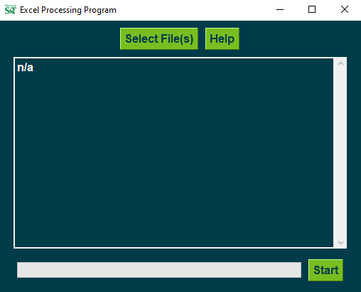

# Select File(s) Button

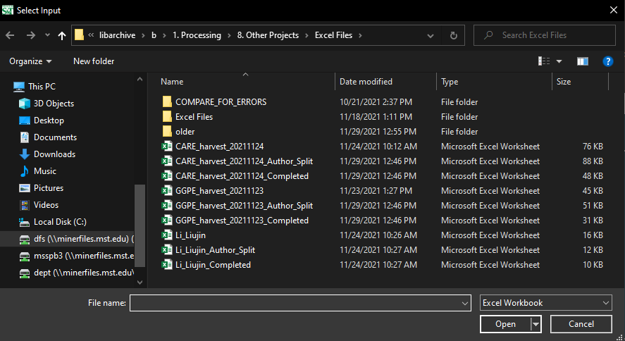**Clicking on the Select File(s) Button will open a File Explorer window.**

## Select One Excel File

* Click on the file
* Click on the **Open** button in the bottom right

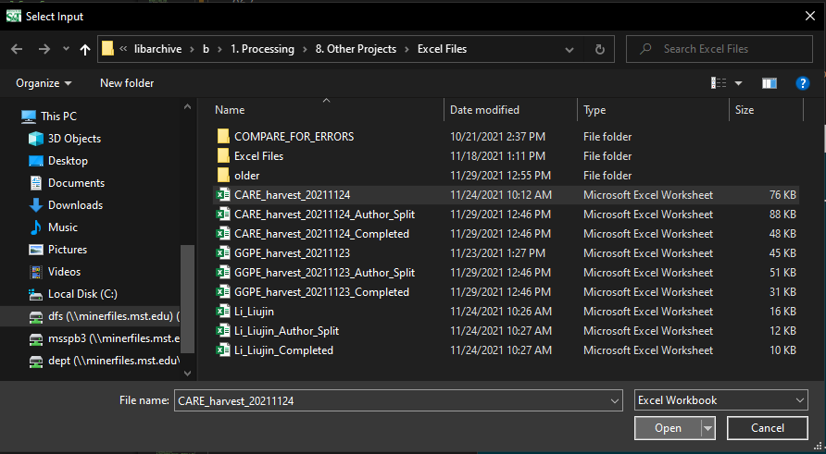

* The file name will appear in the Excel Processing Program

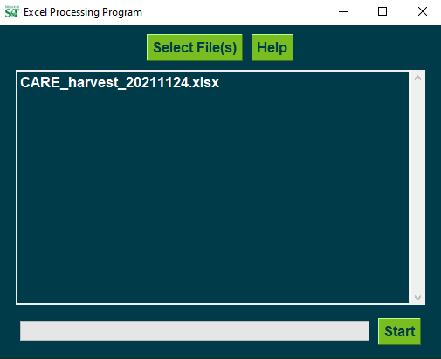

## Select Multiple Excel Files

* Hold the **Ctrl** Key and click on all the files you want to process
* Click on the **Open** button in the bottom right

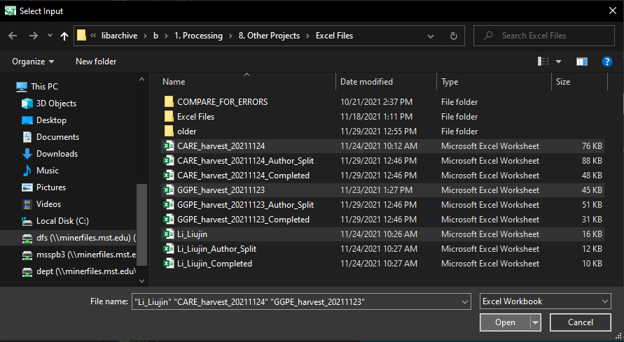

* The file names will appear in the Excel Processing Program

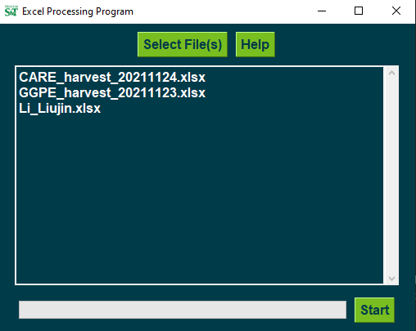

## Scrollbar Bug with Multiple Files Selected

If multiple files are selected and the files do not show completely in the program, the window will need to be resized to update the scrollbar. This is a bug that is being worked on.

To resize the window, hover over any edge until you see a double-sided arrow, click and drag to resize. It does not have to be a major adjustment, even one pixel is enough to update the scrollbar.

Before Resizing Window

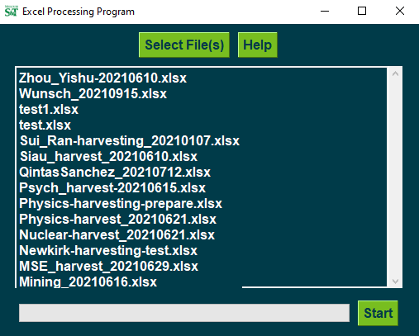

After Resizing Window: The scrollbar now has a darker bar within that can be used to view more files.

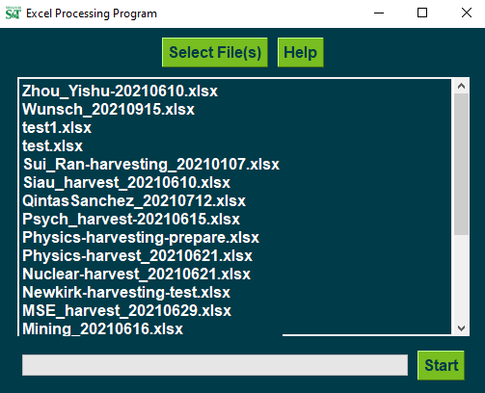

## Cancelling the File Explorer

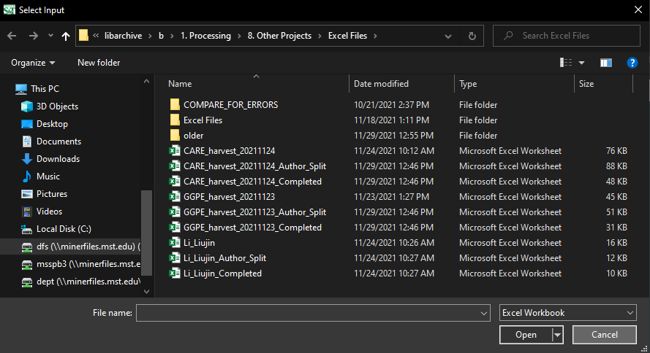

If the **Cancel** button is clicked on instead of the **Open** button in the File Explorer Window, then the following warning pop-up will appear.

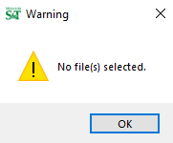

The program can be used after this, just click on the **Select File(s)** button to restart the selection process.

## Processing Multiple Batches

The **Select File(s)** button can be reused multiple times while the program is open.

To be more specific, if the program user selects one or many files from a folder but wishes to process other files in a different folder, the program does not need to be closed. The program user can click on the **Select File(s)** button again to choose more excel files in other locations.

# Help Button

**Clicking on the Help Button will open the Excel Processing Help document.**

# Middle Frame

**The middle frame contains the names of the selected files.**

At the beginning of opening this program, this space will have text that is “n/a”.

Once files are selected, the names will appear in this area.

If the Select File(s) button is cancelled, the text will be “n/a”.

# Progress Bar

**The progress bar shows the progress of the program as it completes the Author Split and Harvesting programs.**

# Start Button

**The Start button begins the Author Split and Harvesting programs.**